
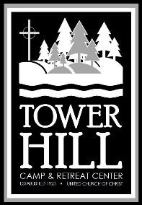
Tower Hill Camp and Retreat Center
12173 Tower Hill Rd, Sawyer, MI 49125
269-426-3881 | www.towerhillcamp.org

Tower Hill is nestled in southwest Michigan on the shores of beautiful Lake Michigan. We offer 30 acres of wooded trails, a private beach on Lake Michigan, a large field for games, a Low Ropes Challenge course, sand volleyball and basketball, as well as cross country skiing in the winter. We have a labyrinth for quiet reflection, and outdoor worship spaces at the cross at Vesper Hill and God’s Mailbox.

2026 TOWER HILL CAMPS AND RETREATS
HUG Camp July 5-10, completed 4th-11th grades, $550
Directors: Carol Currier-Frighetto and Donna Boyko At camp God Helps Us Grow memories and friendships that lasts FOREVER!
HUG Tenderfoot July 8-10, completed K-3rd grade, $330
Director: Tom March Tenderfoot gives younger campers the opportunity to experience camp in an abbreviated timeframe.
Godstock Camp July 19-24, completed 3rd-9th grade, $550
Directors: Jamie Kirscher and Theresa Graben Godstock is a week-long camp where youth can make life-long friendships while connecting with nature and their faith.
Godstock Tenderfoot July 22-24, completed K-3rd grade, $330
Directors: Cindy and Allen White Campers will engage in activities both with and separate from the larger Godstock campers.
Creation Care Camp August 3-6, $300/person
Director: Rev. David Russell An intergenerational gathering for children and adults to come together to immerse themselves and play in Creation.

Brush Harbor Retreat for Clergy of Color October 1-3, $250/person Retreat Leader: Eyvette Jones-Johnson Come to connect deeply with your peers surrounded by the healing power of nature.
Scan to Learn More & Donate
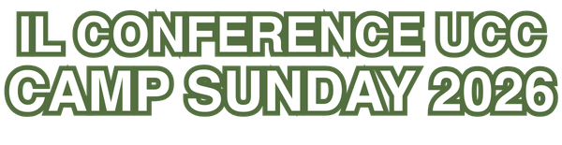

Pilgrim Park Camp and Conference Center
26449 1340 N Avenue, Princeton, IL 61356
815-447-2390 | www.pilgrimparkcamp.org

Pilgrim Park is nestled in a valley in North Central Illinois and sits on 150 acres. The site has wonderful hiking trails, a pond for fishing and paddle boating, and an outdoor labyrinth for quiet contemplation. In addition, there is a fun swinging bridge, an outdoor swimming pool, and an outdoor worship space situated on top of the hill.
2026 PILGRIM PARK CAMPS AND RETREATS
Crafter’s Retreat April 20-23
$411 single, $311 double, $297 triple
Quilt? Scrapbook? Crochet? Knit? Crafts? Come complete your masterpiece in the beautiful peaceful setting at Pilgrim Park.
Sports Camp June 21-27 completed 6th to 9th grades $325
Lead by: Andrew Larsen & Matt Rodgers Sports Camp is wholesome, builds confidence and fosters leadership skills.
Making Memories Camp July 6-8 ages 4+, $255 first, $135 additional
Directors: Lorri Foockle & Karen Karczewski A two-day intergenerational camp for ALL ages/family groups…swimming, crafts, campfire, creek walk, paddleboats, games, archery, and God!
Women’s Sacred Relax and Renewal October 2-3 Full Retreat $173, Day Only $114, Friday only $72, Saturday only $82
Director: Carol Currier-Frighetto
A 23 hour get-a-way to relax while engaging God’s Holy Spirit!
Crafter’s Retreat December 3-6
$411 single, $311 double, $297 triple





What a great time to complete your last-minute gifts for Christmas.
Scan to Learn More & Donate

