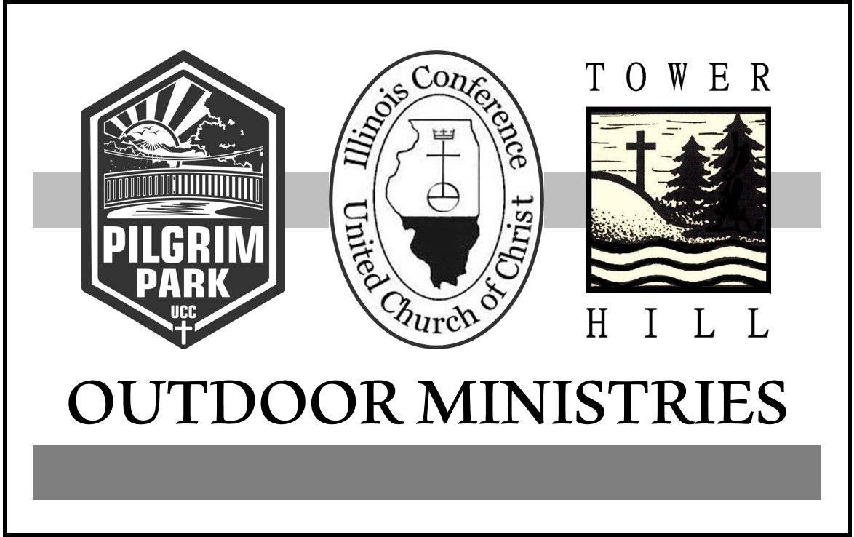

*CALL TO WORSHIP
Cecil Francis Alexander penned these words In 1848, “All things bright and beautiful, all creatures great and small, all things wise and wonderful, the Lord God made them all. Each little flower that opens, each little bird that sings, God made their glowing colors, God made their tiny wings. The tall trees in the greenwood, the meadows where we play, the rushes by the water, we gather every day. God gave us eyes to see them, and lips that we might tell: how great is God almighty, who has made all things well.

*INVOCATION Unison
In the midst of the woods, O God, there is a small clearing where you meet us.
Your gentle breeze fills up our lungs.
Your warm sunlight cascades upon our hearts.
Your footsteps are on the worn path.
You create gifts of time and space set apart so that we might reflect and grow.
May we hear you clearly in camp and retreat experiences,
may we feel you in these times and spaces,
and may we know you walk with us back into the everyday world, rejuvenated by your compassion. Amen.

SCRIPTURE READINGS
1 Kings 4:33
He would speak of trees, from the cedar that is in the Lebanon to the hyssop that grows in the wall; he would speak of animals, and birds, and reptiles, and fish.

Psalm 96:11&12
Let the heavens be glad, and let the earth rejoice; let the sea roar, and all that fills it; let the field exult, and everything in it. Then shall all the trees of the forest sing for joy.
Luke 12:27
Consider the lilies, how they grow: they neither toil nor spin; yet I tell you, even Solomon in all his glory was not clothed like one of these.

The Morning Offering OffErtory video

MESSAGE Pilgrim Park and Tower Hill

*BENEDICTION
Knowing that God is always with you, go in peace my friends.
Take with you your memory of the beauty of God’s natural world;
and in your heart a love that never ends. Amen.

