Help us Erase Medical Debt!
The Illinois Conference “$10M in 10 Weeks”
Initiative is officially underway!

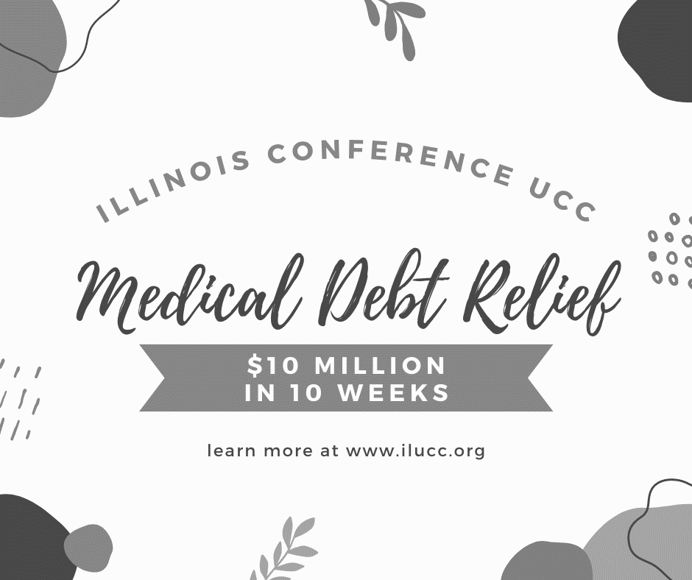

We have a challenge set to relieve $10M of medical debt that is burdening our neighbors right here in Illinois. If we can raise $100,000 by the end of November, we have the opportunity to purchase debt through RIP Medical Debt in partnership with the national setting of the UCC. This amount of money can relieve $10,000,000 of debt off the backs of our neighbors most in need.
SCAN ME TO LEARN MORE!

The Burden of
Medical Debt

Medical debt is a largely unseen epidemic in America. The Illinois Conference has launched a major fundraising effort that will result in the cancellation--the forgiveness--of millions of dollars in medical debt.
- Americans owe debt collection agencies $140 billion in medical debt. Sadly, additional medical debt is also owed to hospitals and other creditors.

- Medical debt affects millions. More than 1 in 6 owe medical debt to a collection agency. Even when people have insurance, uncovered out-of-pocket costs often exceed their means. It is likely that you or someone you know has struggled, or struggles now, with such debt. Black Americans are especially hard hit; in 2015, nearly 1 in 3 Black adults under 65 carried medical debt.

- It's not just the huge bills: Many people think of medical debt as the crushing burden of $10,000-plus medical bills. Often this is true. But much smaller amounts in collections are also common. Amounts under $1,000 that might be "modest" for some of us are daunting for many. Given the consequences of not paying the rent or electric bill vs. not paying $500 in medical bills, rent and electric win out every time. But the unpaid medical bills--large and small--accumulate, ruin credit, and cause chronic stress.

- It's not about "discretionary spending": Circumstances force people to seek medical care when they would rather not. Emergencies need immediate attention. Other medical problems must be treated despite the expense. "Comparison shopping" for the best price is often impossible, or impractical.

