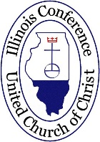
Illinois Conference
2021 Medical Debt
Relief Campaign
We have an exciting challenge that we can only possibly achieve if we work together. After all, we are STRONGER TOGETHER.

We have a challenge set to relieve $10M of medical debt that is burdening our neighbors right here in Illinois. If we can raise $100,000 by the end of November, we have the opportunity to purchase debt through RIP Medical Debt in partnership with the national setting of the UCC. This amount of money can relieve $10,000,000 of debt off the backs of our neighbors most in need. I know no better way to express our faith in practice!

I invite you each to give what you can – but better yet, motivate your congregation to give! If your congregation could raise $10,000 – that would be $1M of debt! If your missions committee could allocate $1,000 – that would be $100,000! If your Sunday School class could scrape together $100 – that would be $10,000 that another family will be freed from.

The United Church of Christ is committed to creating a just world for all – and how better to put this concept into practice than to lift the burden of medical debt, especially during this season of pandemic.

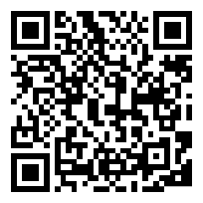
A great way to give THANKS. A great way to celebrate the HOLIDAYS. A great way to live out our FAITH.
SCAN ME TO LEARN MORE!

Blessings,
Rev. Molly Carlson
Conference Minister

P.S. Consider making a donation in the name of that family member that is hard to buy for – what a great gift!

