Announcing: The Eastern Association Spring Meeting
“We Are Alive: 2.0”
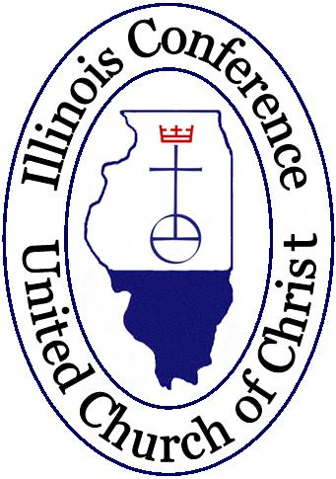
Saturday, April 6, 2019
9:30 – 10:00 a.m. Registration
St. Paul’s United Church of Christ
5323 Margaret St., Monee, IL 60449

REGISTRATION INFO (Please Print Legibly):
Name:
Name as it should appear on Nametag:
Church & Town:
Home Address:
Home Phone: ( ) Day/Cell Phone: ( )
Email Address (PLEASE PRINT):
PLEASE CHECK ALL THAT APPLY:
Adult Delegate ____Adult Visitor Youth Delegate Youth Visitor ____Laity
____Retired Clergy & Spouse/Partner ________Clergy Member-in-Discernment
Special Needs (Please Specify):
Vegetarian Meal Childcare Needed**
**Please give Name(s) & Age(s) of Child(ren) if Childcare is checked above:

Please complete both sides of registration form!!!

REGISTRATION FEE: (Please Circle appropriate amount)
Adult: $20.00 Youth: $10.00

Member-In-Discernment or Retired Clergy & Spouse/Partner: Free

Please copy this form and send a completed one for EACH ATTENDEE
Also be sure to enclose the appropriate Registration Fee.

Make checks payable to: Illinois Conference UCC
Note: You may include one check for all attendees if desired

MAIL THIS ENTIRE FORM WITH PAYMENT BY Friday, March 29th TO:

Western Association Office: 1409 R Kelly Ave., Peoria Heights, IL 61616
OR:
Scan Form and Email to Western Association office: ilwestucc@aol.com
OR:
Phone Reservation to Connie Owens at the Western Office: (309) 685-5929

SPECIAL NOTE: Please remember the Association must pay for all registered meals so if you decide not to attend at the last minute (other than an emergency) and have not prepaid you may be asked to reimburse the Association for your meal ticket.

