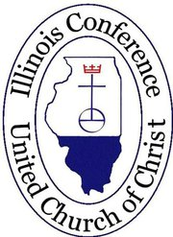
The Fox Valley & The Chicago Metropolitan Associations
of the Illinois Conference, United Church of Christ
Invite You to our 6th Annual Joint Fall Meeting
October 15, 2016
St. Paul UCC, 144 East Palatine Road, Palatine, IL 60067

The blessings of the fall season to all. We invite everyone to gather at St. Paul United Church of Christ in Palatine, Illinois on Saturday October 15, 2016 for our Annual Fall meeting, “Called to Sacred Justice.” It is the 6th time our Associations have met together in unity and partnership.

It is our honor to welcome our Keynote speaker, The Reverend Doctor Michael L. Pfleger of The Faith Community of St. Sabina in Chicago. Self-described as “pastor, preacher, parent, lecturer, activist,” Father Pfleger is well-known throughout the country as an outspoken advocate for racial justice and outspoken critic of the systemic violence which plagues Chicago and our nation. We will be challenged by his words to us.

We encourage lay people, clergy, our UCC partners, and everyone to attend. Our meeting will begin with on-site registration and continental breakfast at 8:00. Worship with Sacrament of Holy Communion begins at 9:00. Rev. David Mercer, our host pastor, will preach. Rev. Pfleger’s presentation follows worship. There will be a time for questions and answers after his talk. Our day will conclude with lunch for all at 12:30.

There will be a separate youth event that will run concurrently with our program. The program is intended for children and youth ages 8-23. They will meet together to worship, to discuss the topics of the day and to share a time of fellowship. This program is sponsored by “Off the Pews,” a program that began in Cluster Six of the CMA but whose success has allowed them to expand to reach a wider audience. A flyer for this event is included in this meeting information packet. There is a separate registration process for this event.

The Metra train schedule to Palatine was not accommodating to our meeting times. But we encourage all attendees to share rides and carpool especially given the wider profile of our keynote speaker.

The registration fee for the joint Association meeting is $25 if you register by Friday, October 7th, increasing to $30 if you miss the deadline or register the day of the event. Your fee includes the presentation and all food. There is a reduced registration fee of $15 for Members-in-Discernment and Retired Clergy. Please register one person per form. Please make additional copies as needed. Early registration is greatly appreciated. Early registration deadline is Friday, October 7, 2016.

If you have questions, contact the CMA Administrative Assistant, Rev. Wayne MacPherson (ilconfwayne@gmail.com or 773-324-7650).

Ms. Ann McCarthy
Moderator – Chicago Metropolitan Association
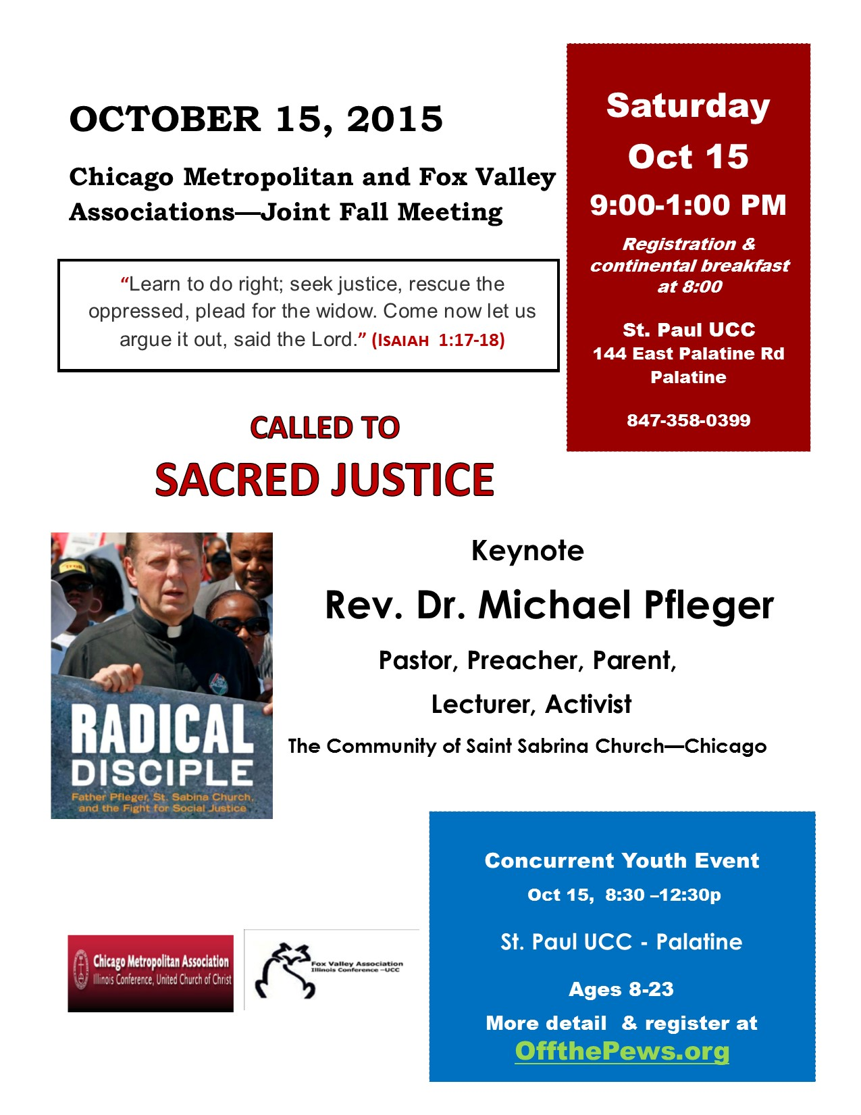

Chicago Metropolitan & Fox Valley Associations Annual Fall Meeting
St. Paul United Church of Christ
144 East Palatine Road, Palatine IL
Saturday, October 15, 2016 - Registration Opens at 8:00 am

REGISTRATION FORM - Deadline 10/7/2016

Please submit a separate form for each registrant. Photocopies are acceptable.

Name: ________________________________________________________________________

Church Membership or Agency: ____________________________ City ____________________

Association (please circle one) CMA FVA Other

Are you part of pastoral or lay leadership of your church? (If yes, circle one)
Pastoral Lay Leadership

Address (please circle one): church home workplace

_____________________________________________________________________________________
(Street) (City) (State) (Zip)

Telephone: ___________________ (Home, cell, or work?) E-mail: ______________________

******************************************************************************
Child Care Needed: YES/NO (Please circle) Number of children: ______ Ages: _________________

Special Dietary or Other Needs: ______________________________________________________________

Do you need display space? Organization Name: ___________________________________________

The registration fee is $25 ($30 after 10/7/2016) $15 for Members-in-Discernment and Retired Clergy. Registration includes meeting materials, continental breakfast and lunch. Please make checks payable to the Illinois Conference United Church of Christ.
Please return form with check to the appropriate Association office. Deadline: 10/7/2016_
Chicago Metropolitan Association Members
1407 East 60th Street
Chicago, IL 60637
Telephone: 773.324.7650
Copy may be faxed to: 773-324-7692
Email: ilconfwayne@gmail.com

Fox Valley Association Members
1840 Westchester Blvd. Suite 200
Westchester, IL 60154
Telephone: 708.344.4470
Copy may be faxed to: 708-344-4564
Email: ilconferenceucc@gmail.com

Driving Directions to St. Paul UCC
144 E. Palatine Road, Palatine, Illinois 60067
From the North: Take 94 East to Lake Cook Road. Exit at Lake Cook Road and go west to Rt. 53. Take 53 south to West Palatine Road. Exit at West Palatine Road and go for about 2 miles. When you see the Walgreens at the intersection of West Palatine Road and Northwest Highway (Rt. 14), you are getting close. Continue straight on West Palatine Road and the church is down two blocks on the right.
From the South: Take 294 West to I-90 West. I-90 West to Rt. 53 North. 53 North to Northwest Highway. Stay to the right and go west on Northwest Highway. When you exit at Northwest Highway, you should see Harvest Bible Chapel on your left. It is a large, former warehouse that has been converted into a church. Stay on Northwest Highway for a couple of miles until you come to the intersection with West Palatine Road. A Shell gas station will be on your right and a Walgreens will sit kitty corner on the left. Turn left there and St. Paul will be down two blocks on the right.
From the East: Lake-Cook Road west to Rt. 53. Take Rt. 53 south to West Palatine Road. Exit at West Palatine Road and go for about 2 miles. When you see the Walgreens at the intersection of West Palatine Road and Northwest Highway (Rt. 14), you are getting close. Continue straight on West Palatine Road and the church is down two blocks on the right.
From the West: Take I-90 East to Rt. 53 North. 53 North to Northwest Highway. Stay to the right and go west on Northwest Highway. When you exit at Northwest Highway, you should see Harvest Bible Chapel on your left. It is a large, former warehouse that has been converted into a church. Stay on Northwest Highway for a couple of miles until you come to the intersection with West Palatine Road. A Shell gas station will be on your right and a Walgreens will sit kitty corner on the left. Turn left there and St. Paul will be down two blocks on the right.

